**Day-3. Practice problems on stings**

**17.** Write a C program that takes two strings as input and concatenates them.

**Problem Solution**

1. Take the two strings as input.  
2. Concatenate the second string to the first string.  
3. Print the concatenated string.

**Input:**  
Enter the first string: “Sanfoundry”  
Enter the second string: “Programming”

**Output:**  
Concatenated string = SanfoundryProgramming.

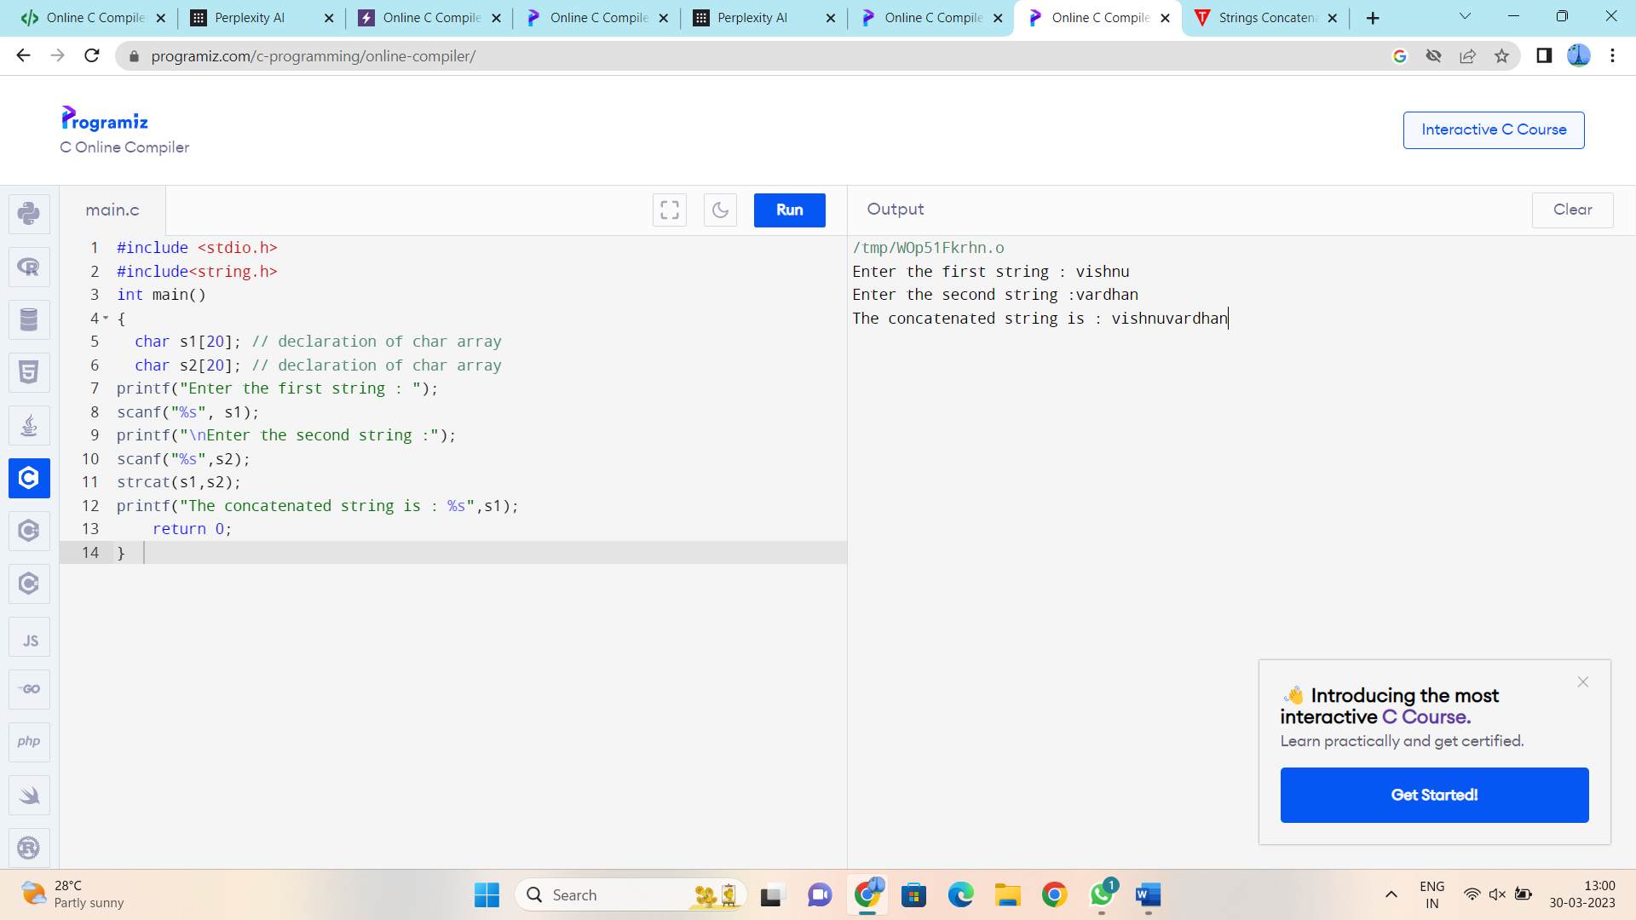

18. Write a C Program to compare two strings.

String is a sequence of characters terminated by the special character ‘\0’. Strings can be compared with or without using the string function.

**Example:**

String1=”Hello” String2=”Hello” Both string are equal

String1=”Hello” String2=”Hell” String1 is greater

String1=”Hello” String2=”Helz” String2 is greater

**Problem Solution**

1. Take two strings as input.  
   2. Compare the two strings and display the result whether both are equal, or first string is greater than the second or the first string is less than the second string.  
   3.Exit

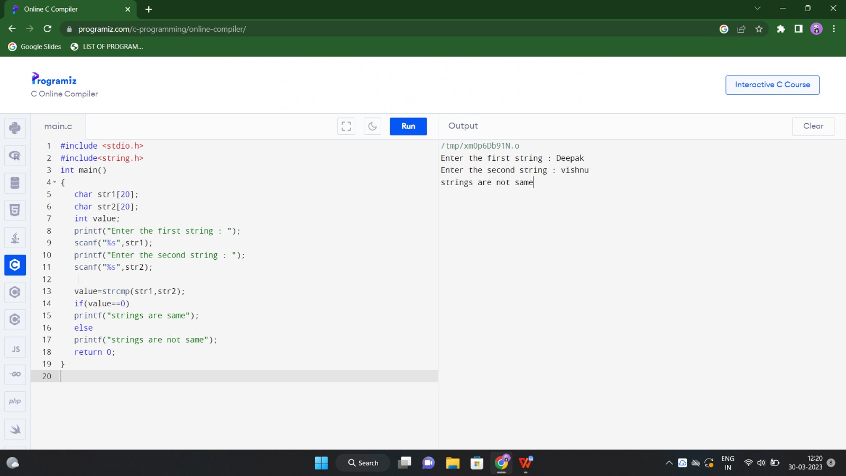

20. This is a C Program to replace all the characters by lowercase.

**Problem Description**

This is a C Program to replace all the characters by lowercase.

**Problem Solution**

1. Take a string as input.  
2. Use string function strlwr to replace all the characters by lowercase.

**Input a string to convert to lower case**

CHANDANA chanikya

rAVELLA

**Input string in lower case:**

chandana chanikya

ravella

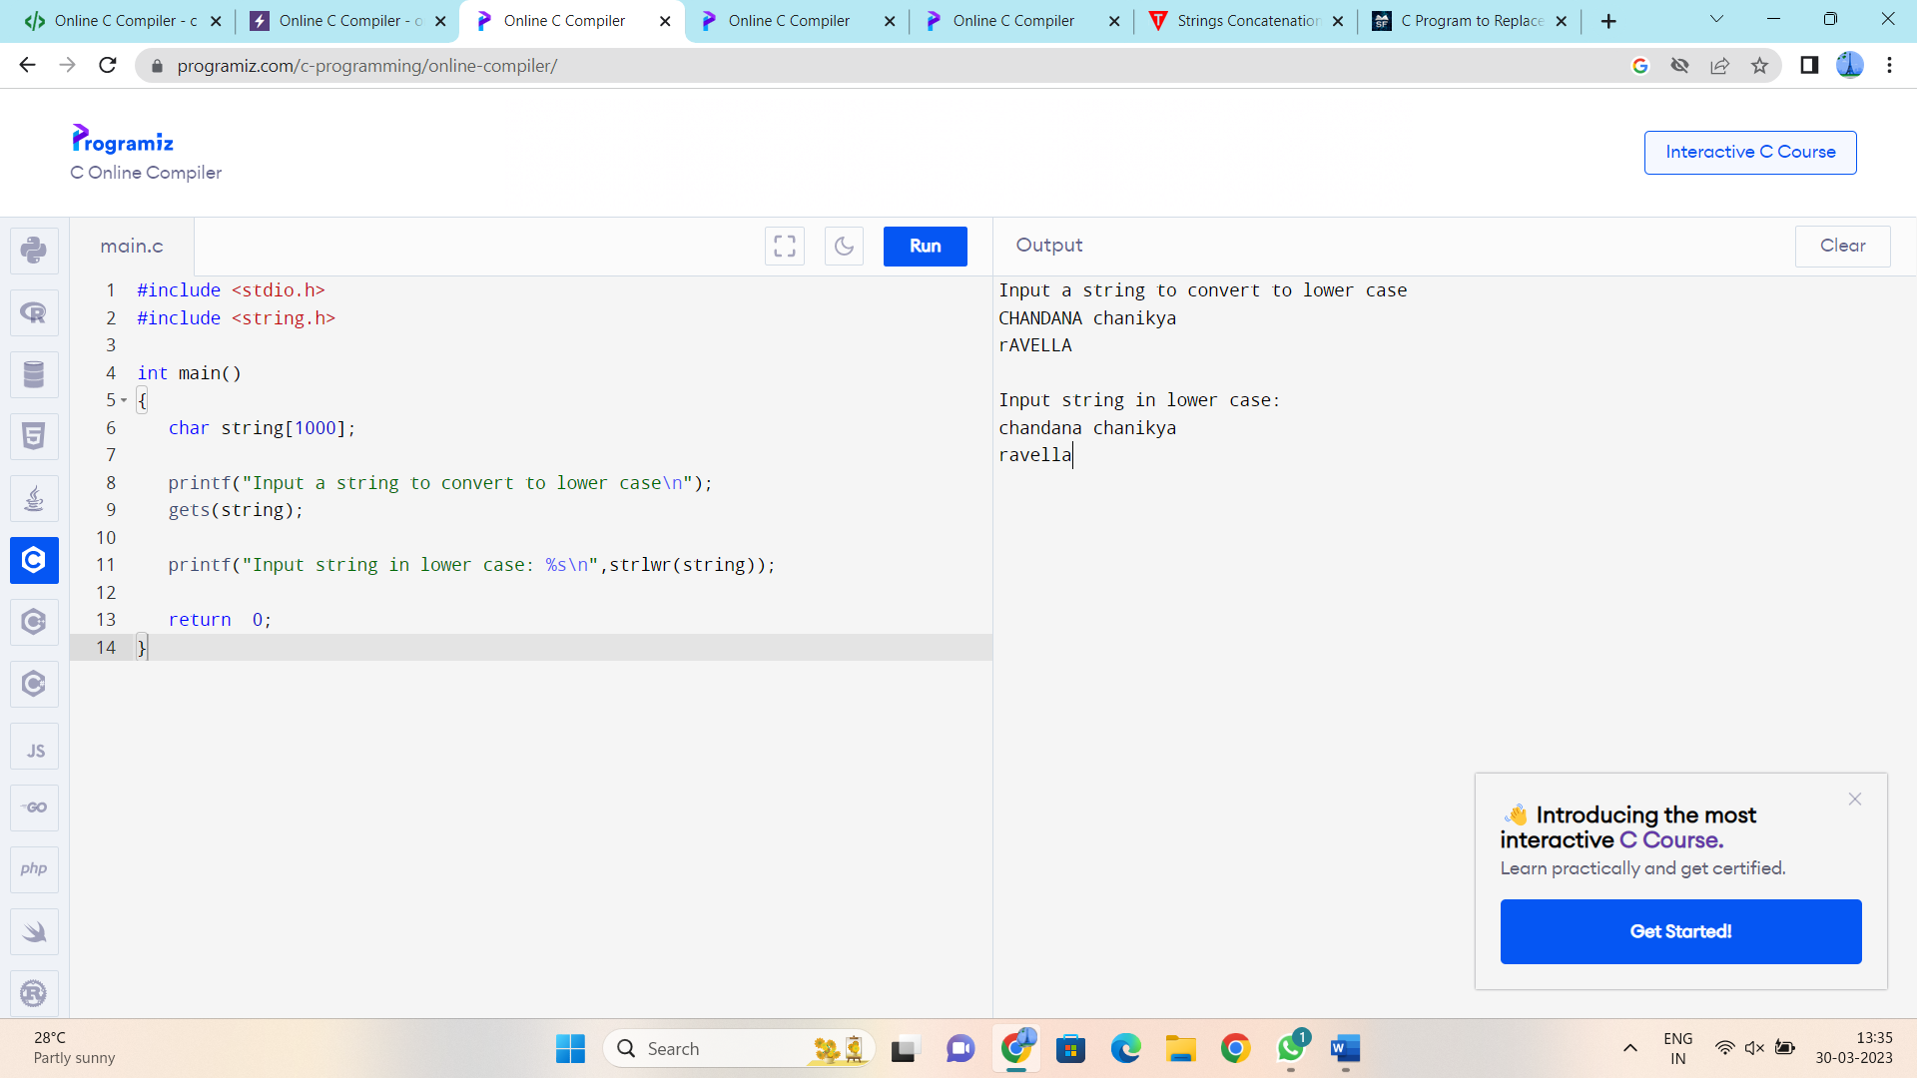

21. Reverse a String in C: Reversing a string means replacing the last element in the first position and vice versa and doing it for all characters in a string. For example, the first character is swapped with the last character, the second character is swapped with the second last character and so on.

A string whose reverse string is the same as the original string is called a palindrome.

**Examples:**

**Input string:** “hello”  
**Reversed String:** “olleh”

**Input string:** “Sanfoundry C Programming”  
**Reversed string:** “gnimmargorP C yrdnuofnaS”

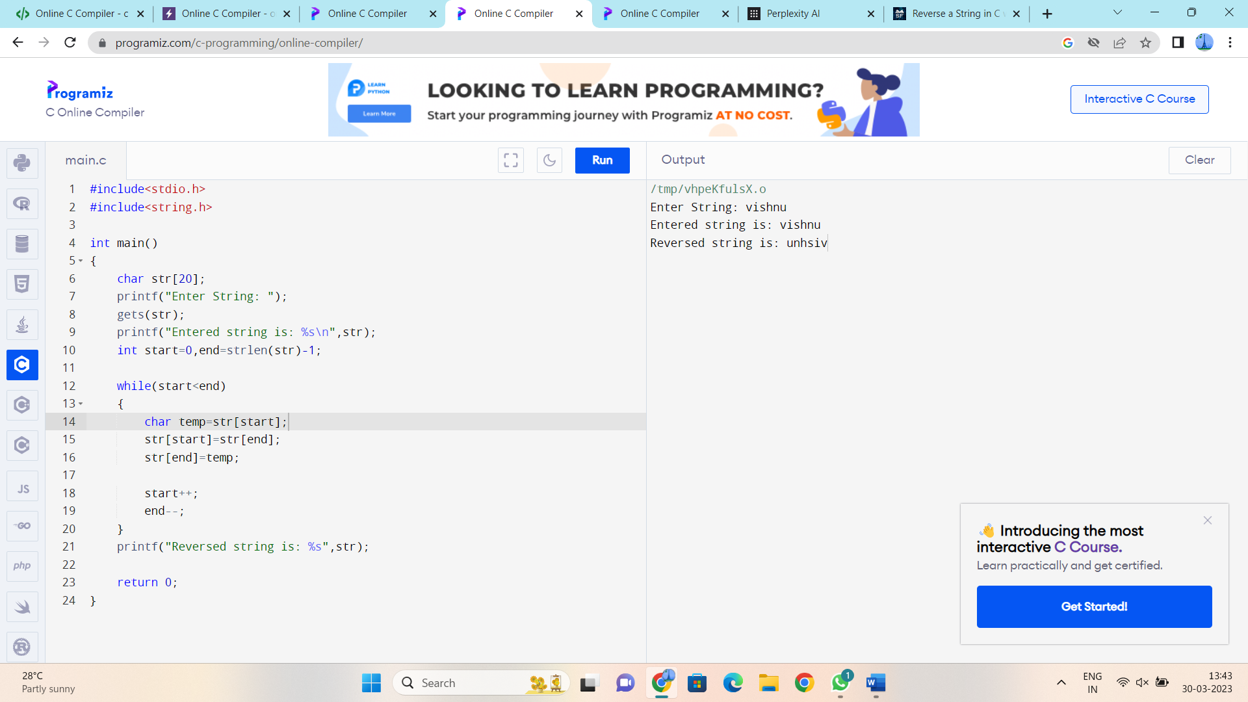

22. Write a C program to find length of a string using loop. How to find length of a string without using in-built library function strlen() in C programming. Effective way to find length of a string without using strlen() function. How to find length of a string using strlen() string function.

**Example**

**Input**

Input string: I love programming. I love Codeforwin.

**Output**

Length of string: 38

